**BUSINESS LOCATION ANALYSIS**

Q1.

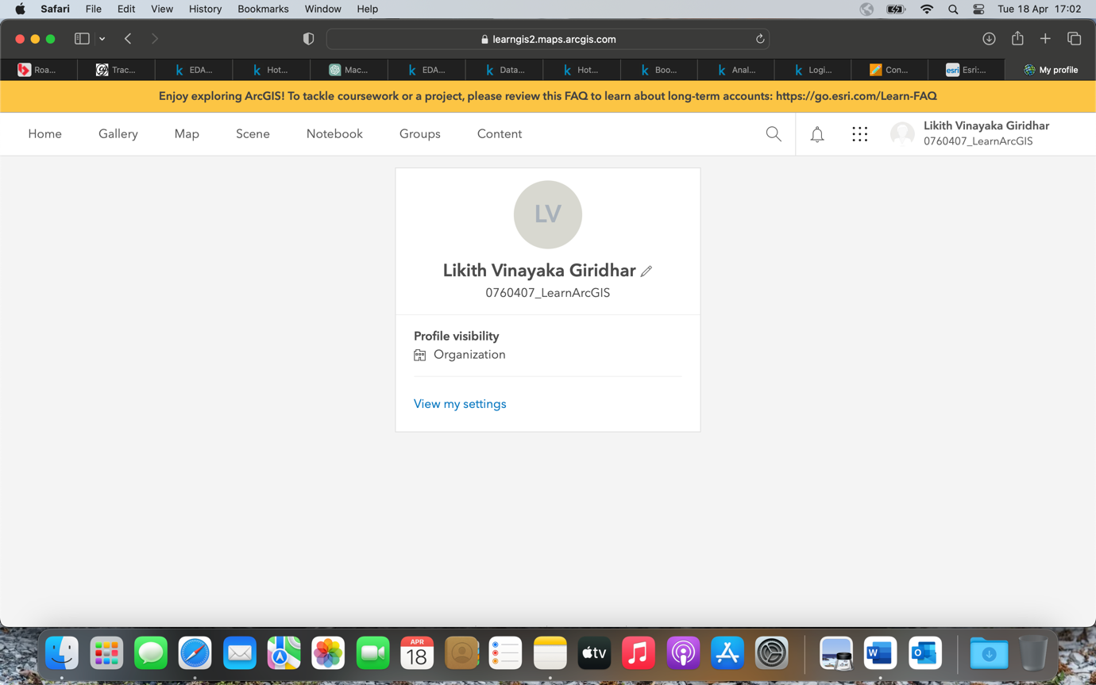

Q2.

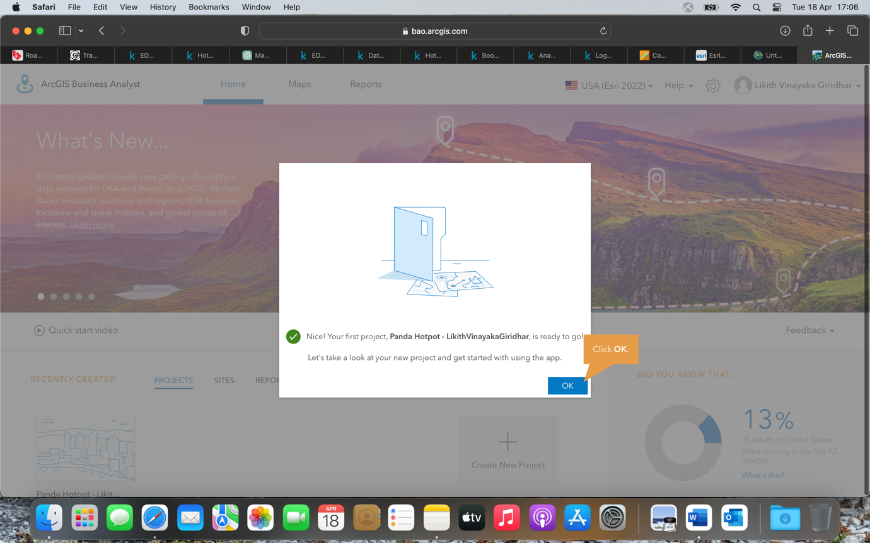

Q3.

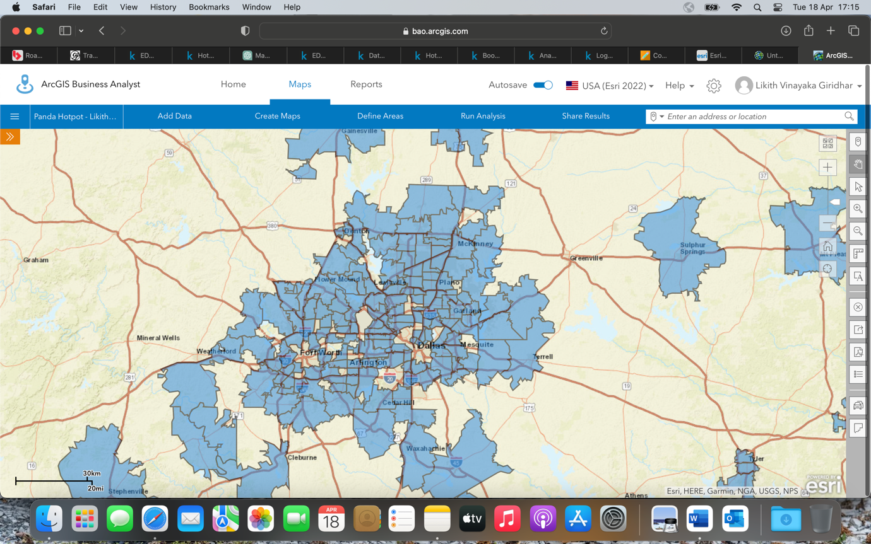

Q4.

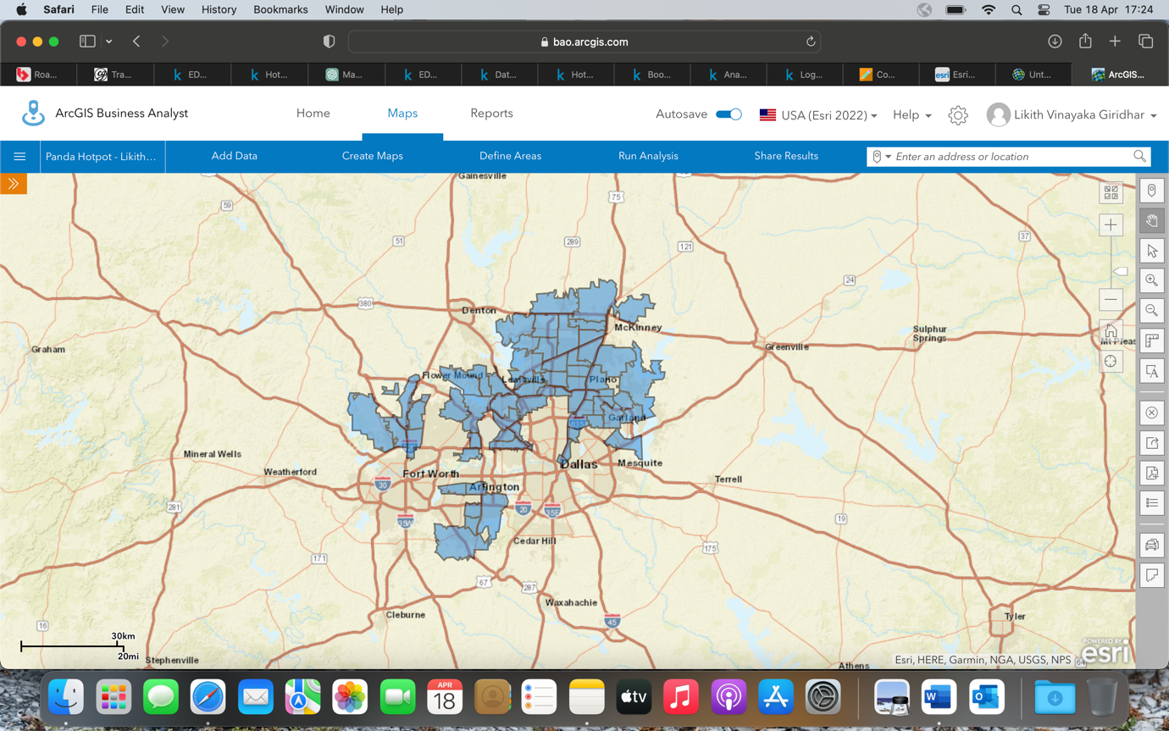

Q5.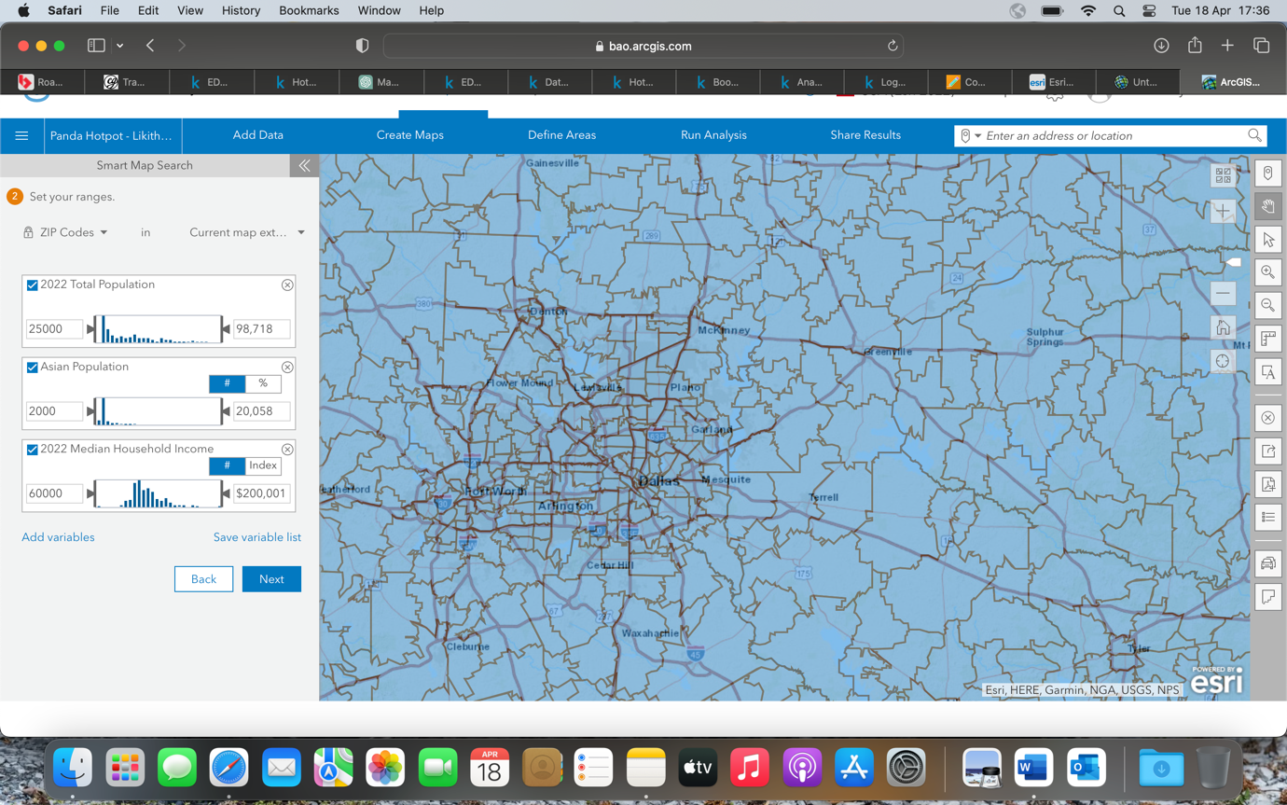

Q6.

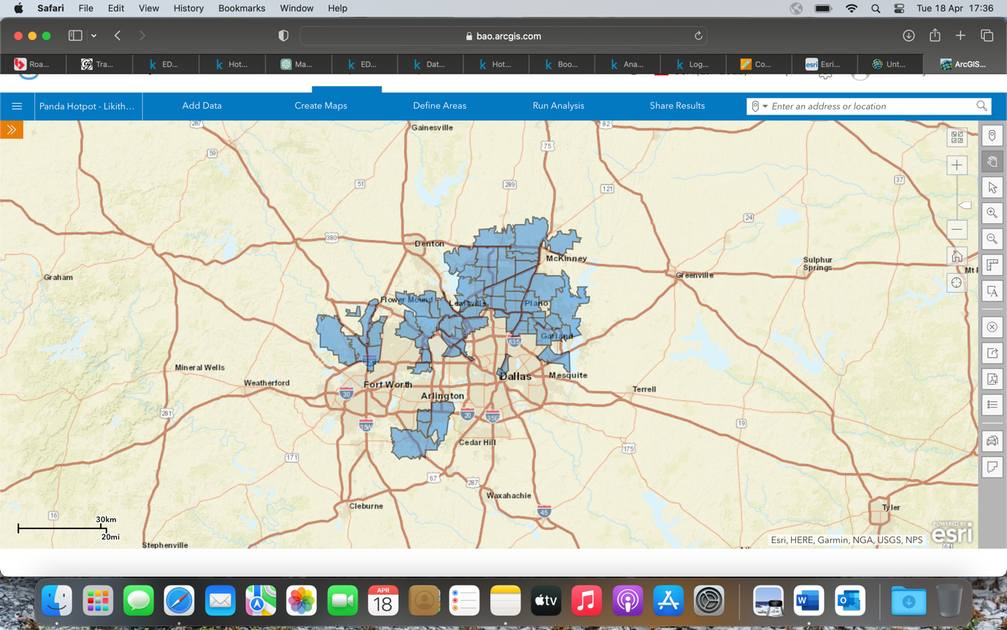

Q7.

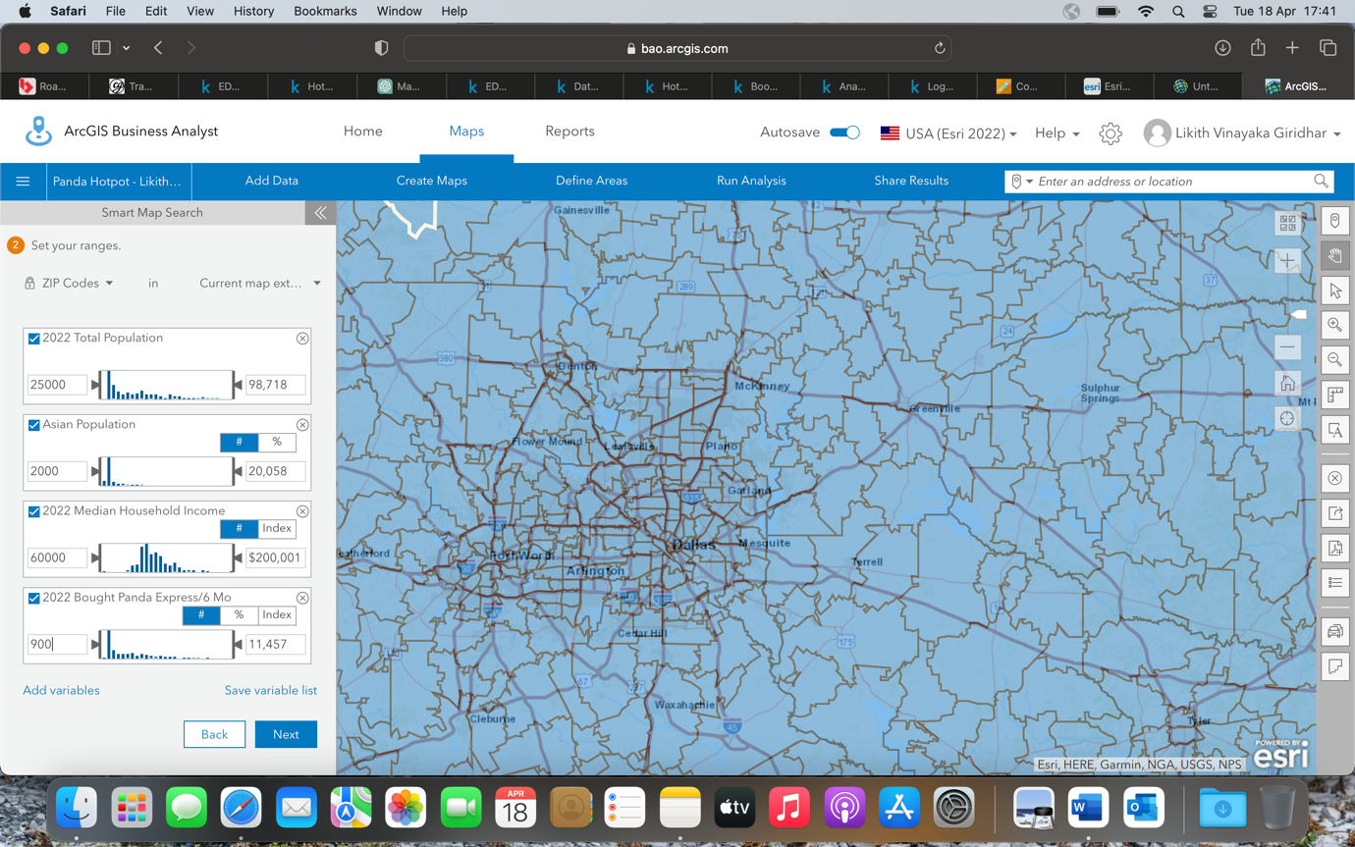

Q8.

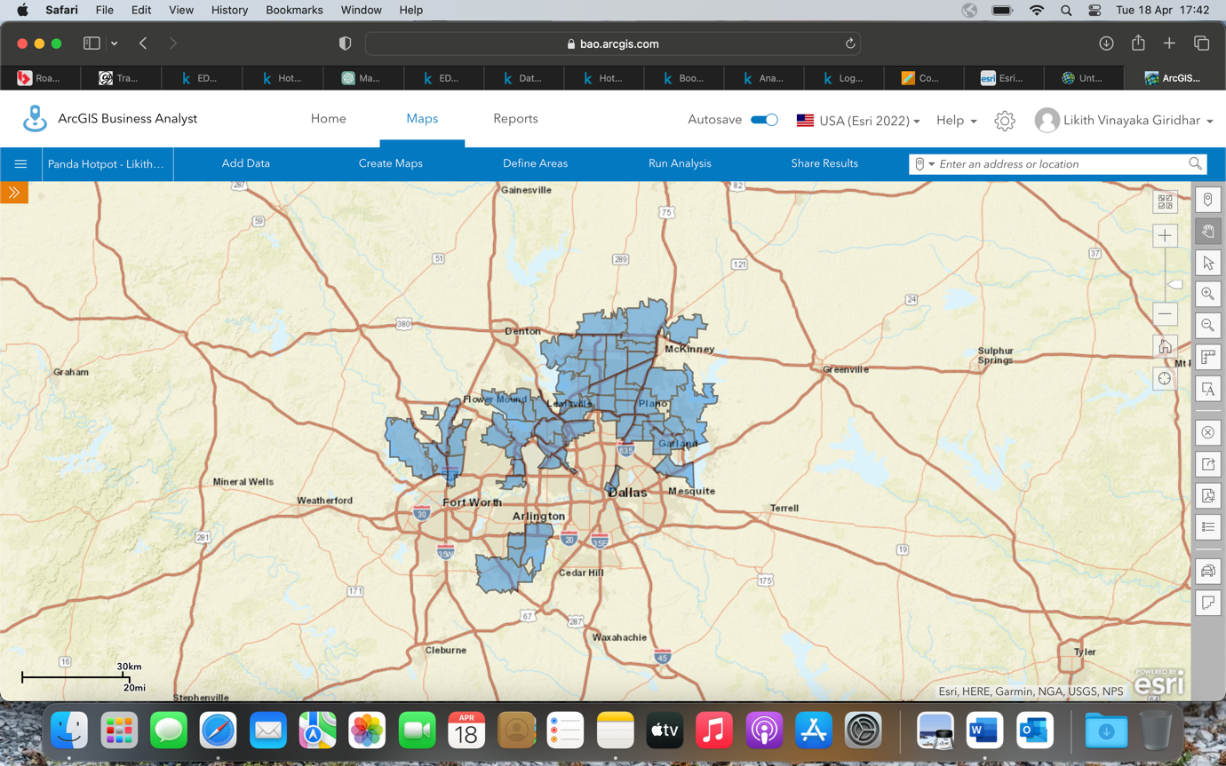

Q9.

**Customer Profile 1:** 2022 Boomburbs (1C) Tapestry Adult Population (Esri)

**Customer Profile 2:** 2022 Laptops and Lattes (3A) Tapestry Adult Population (Esri)

**Customer Profile 3:** 2022 Trendsetters (3C) Tapestry Adult Population (Esri)

**Customer Profile 4:** 2022 Up and Coming Families (7A) Tapestry Adult Population (Esri)

**Customer Profile 5:** 2022 Young and Restless (11B) Tapestry Adult Population (Esri)

Q10.

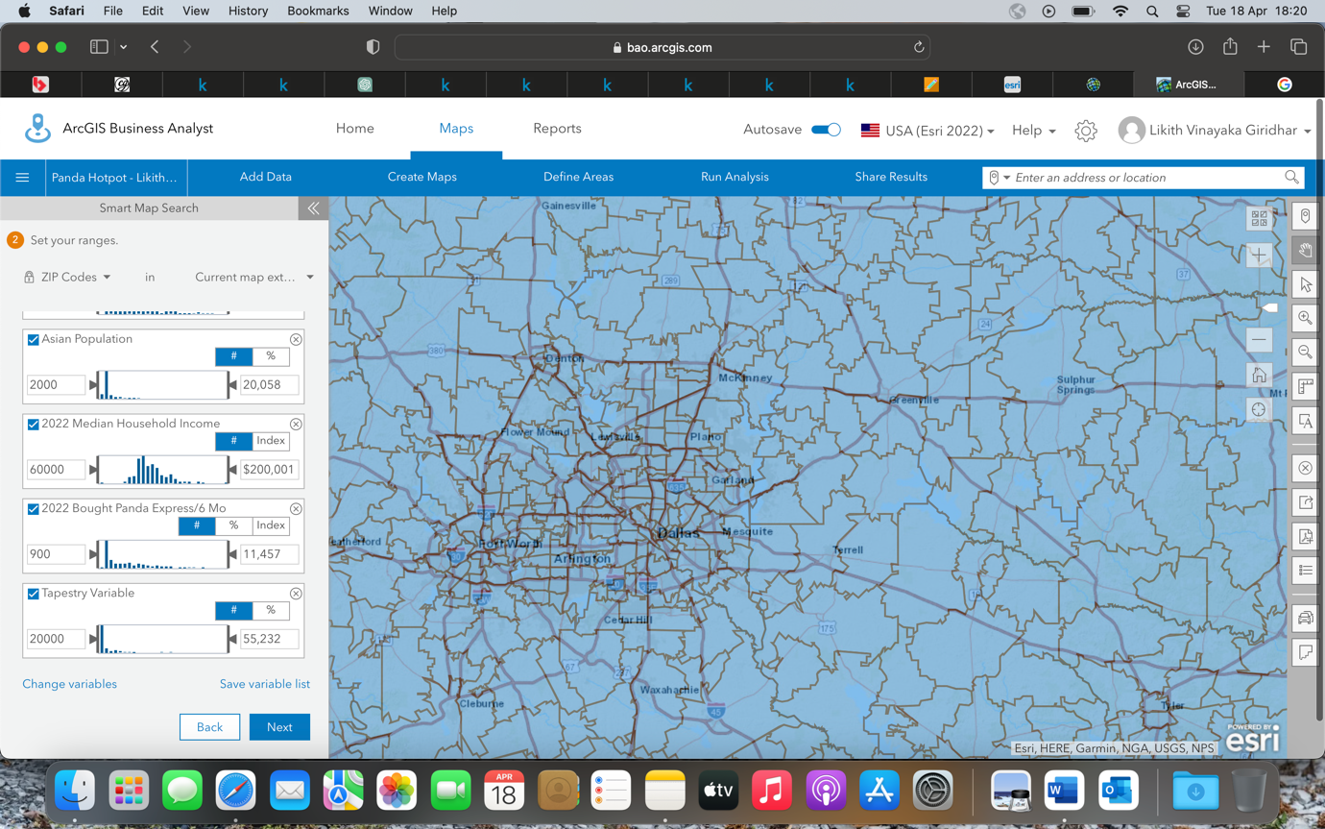

Q11.

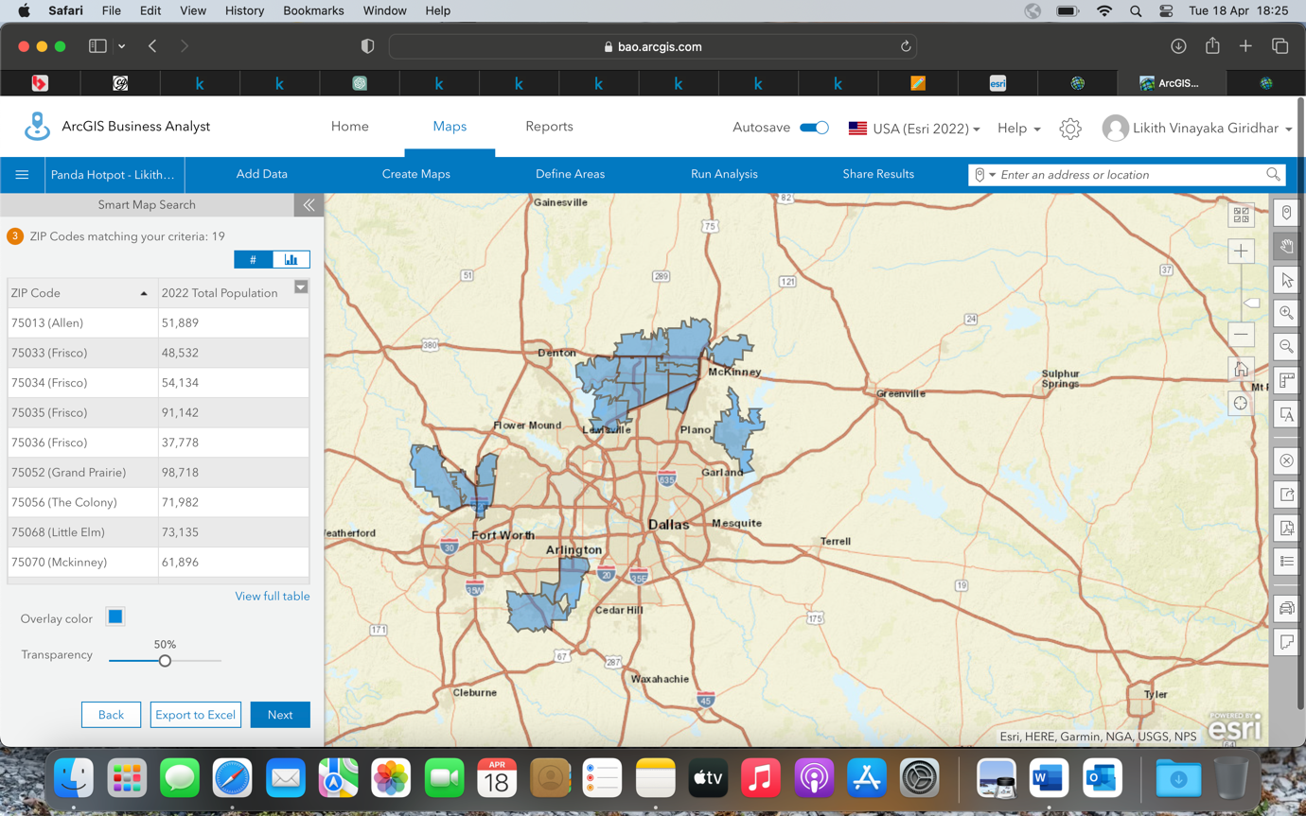

Q12.

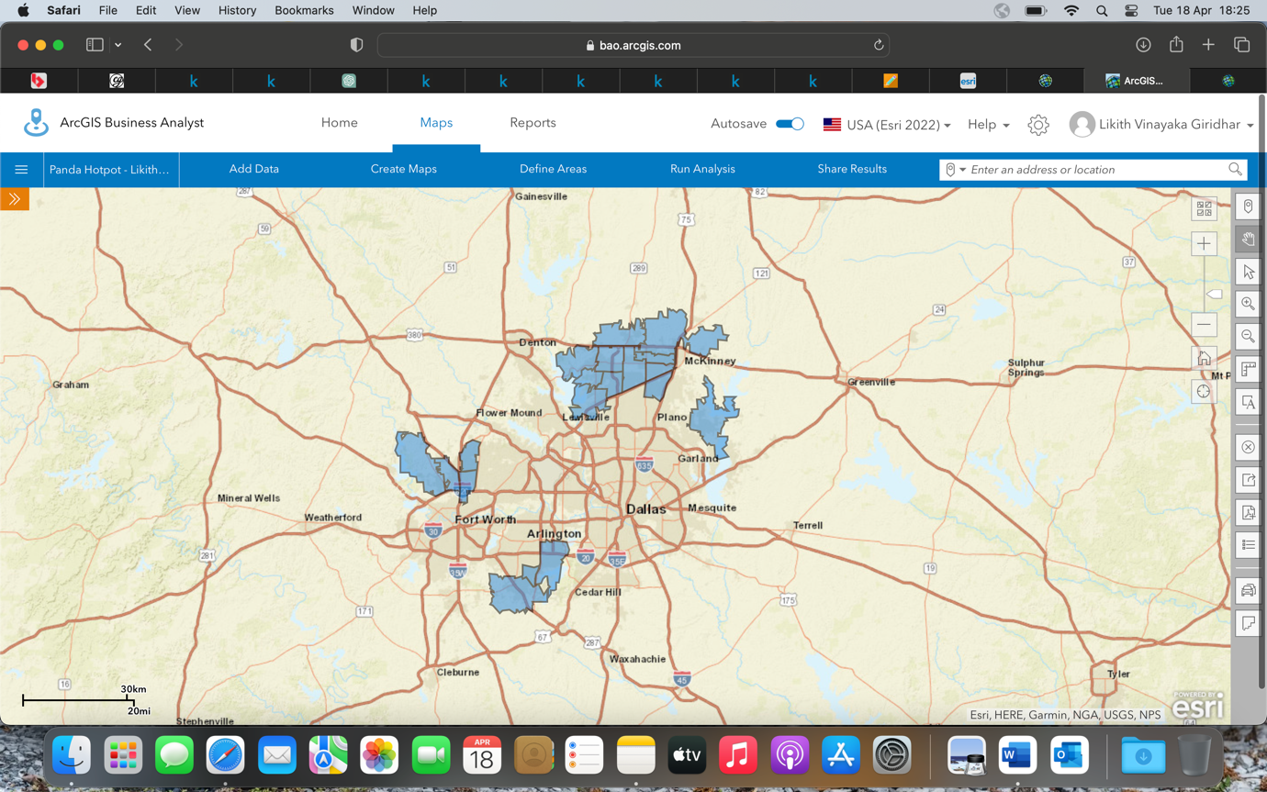

Q13.

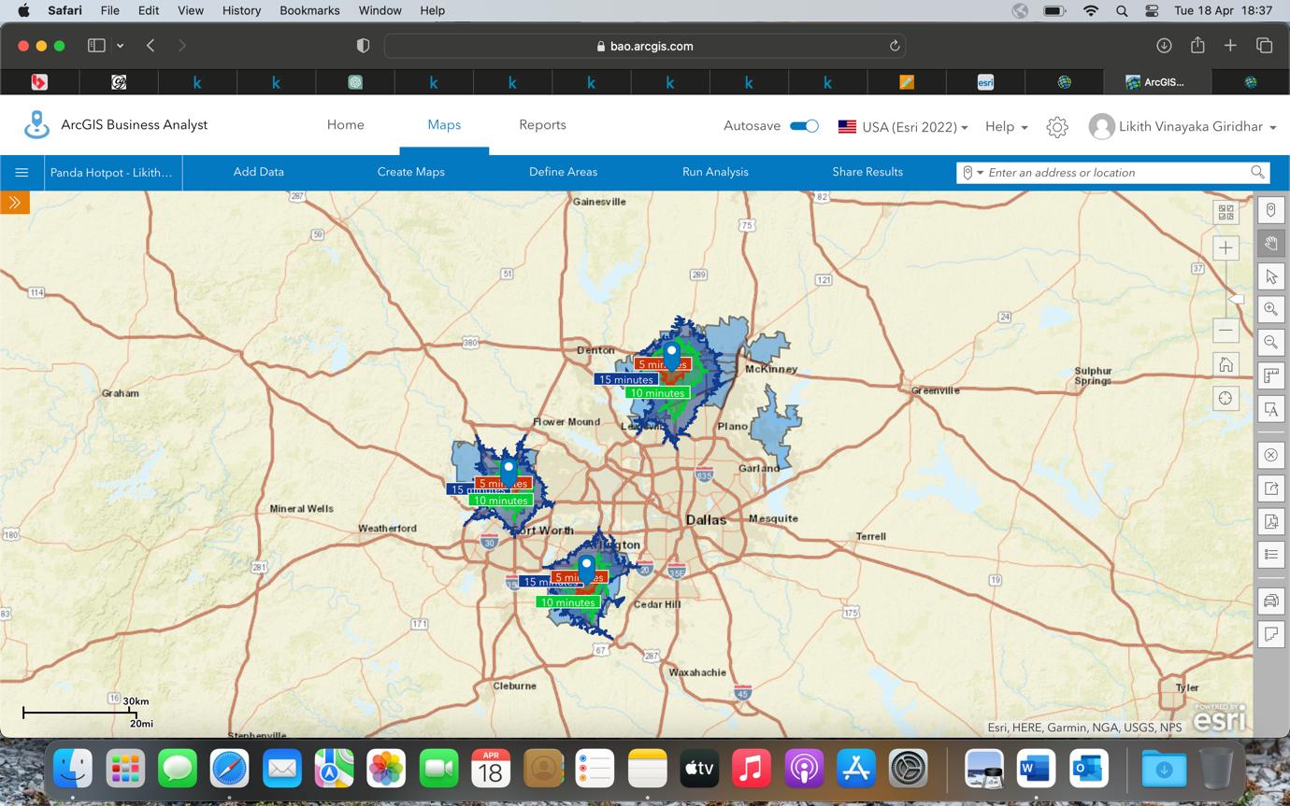

Q14.

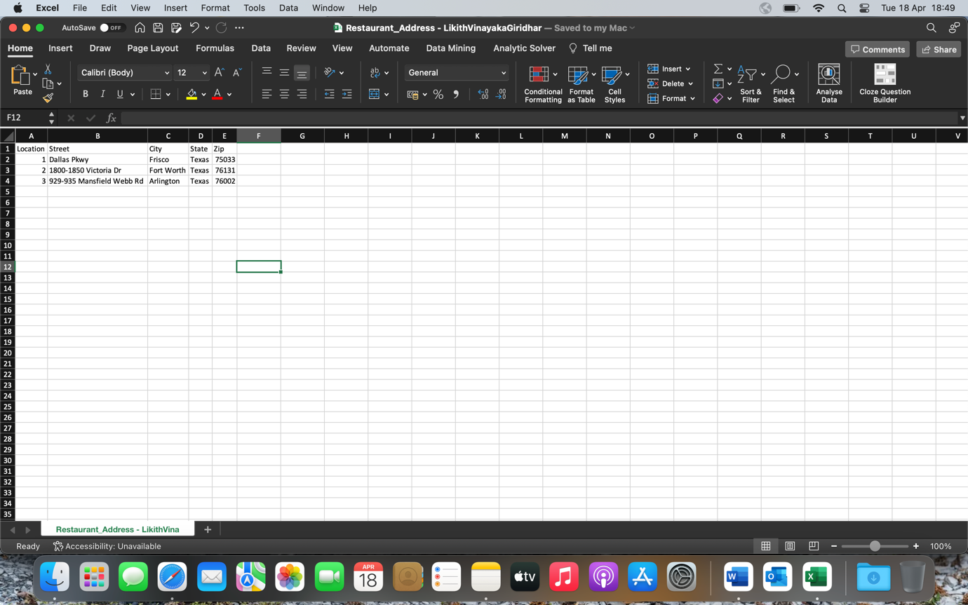

Q15.

Location 1: X: -96.839494 Y: 33.18939

Location 2: X: -97.097852 Y: 32.623594

Location 3: X: -97.335834 Y: 32.874579

Q16.

